 | 17.1.2 Editors - Timeline - View Menu
Table of content
View Menu 1
Sidebar 1
Adjust Last Operation 2
Channels 2
Zoom In 2
Zoom Out 2
Zoom Border 2
Frame All 2
Go to current Frame 2
Frame Scene Range 2
Frame Preview Range 2
Area 2
Horizontal Split 2
Vertical Split 2
Duplicate Area into New Window 3
Toggle Maximize Area 3
Toggle Full screen Area 3
Close Area 3

View Menu

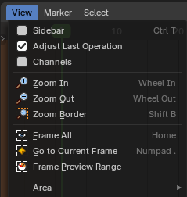
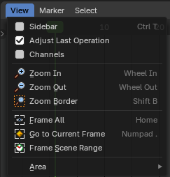
The View menu contains all View related tools.

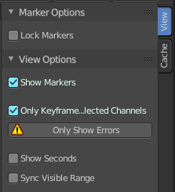
Sidebar
Shows or hides the sidebar at the right in the viewport.

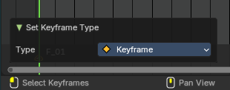
Adjust Last Operation
Shows the adjust last operation panel down left.

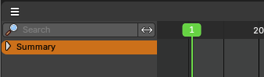
Channels
Shows the channels list at the left

Zoom In
Zooms in.

Zoom Out
Zooms out.

Zoom Border
Draw a rectangle to zoom to the selection.

Frame All
Zooms in or out in the viewport until all objects in the scene are displayed fitting in the viewport.

Go to current Frame
Centers the view at the frame slider.

Frame Scene Range
With Use Preview Range off , reset the horizontal view to the current scene frame range.

Frame Preview Range
With Use Preview Range on , reset the horizontal view to the current preview frame range.

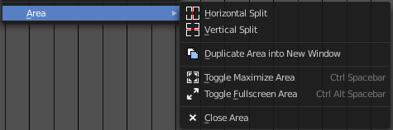
Area
This menu contains general view functionality. And exists in most other editor types too.

Horizontal Split
Splits the current view horizontally into two independent editor windows.

Vertical Split
Splits the current view vertically into two independent editor windows.


Duplicate Area into New Window
Duplicate Area into New Window makes the selected editor window floating. You can then drag it around at the monitor. It is not connected with the rest of the UI anymore.
A separated window cannot be merged into the main window again. You have to close it when not longer needed.

Toggle Maximize Area
Displays the editor maximized with menus.
To return from the maximized view press hotkey ctrl + spacebar. Or reuse the menu item in the area menu.

Toggle Full screen Area
Displays the editor maximized without menus.
To return from the full screen view press hotkey ctrl + alt + spacebar.

Close Area
Closes the area window.

